Experiment 1: Components of a Basic Cellular System
Question (Q1): Use Figma to create an interactive diagram illustrating the components of a basic cellular system.

Aim
To design an interactive diagram showing the main components of a basic cellular system and their interfaces.

Theory
A cellular system divides a service area into cells served by base transceiver stations (BTS). A mobile station communicates with the BTS over the Um radio interface. BTSs connect through a base station controller (BSC) to a mobile switching centre (MSC). HLR, VLR, AuC and EIR support subscriber, mobility and security functions, while gateways connect to external networks.

Procedure
- Create a 1440 × 900 px frame named Cellular_System_Overview.
- Draw containers for Mobile Station, BSS, NSS and External Networks.
- Add blocks for ME, SIM, BTS, BSC, MSC, VLR, HLR, AuC, EIR, GMSC and OMC.
- Connect them with arrows and label interfaces such as Um, Abis and A.
- Add a seven-cell hexagon cluster to illustrate cellular coverage and frequency reuse.
- Create overlay frames with each component’s function, then use Prototype mode to link each block to its overlay with On click → Open overlay.
- Add close buttons and test in Present mode.

Components and Their Functions
- ME: handset hardware identified by IMEI.
- SIM: subscriber identity and authentication information.
- BTS: radio transmitter/receiver for a cell.
- BSC: controls BTSs and radio resources.
- MSC: switches calls and manages mobility.
- VLR: temporary subscriber information.
- HLR: permanent subscriber profile.
- AuC: supports authentication.
- EIR: equipment identity status.
- GMSC: routes calls to external networks.
- OMC: network monitoring and maintenance.

Output Design
A labeled diagram showing the mobile station, BSS, NSS, external networks, interfaces and cell cluster. Insert the Figma screenshot here.
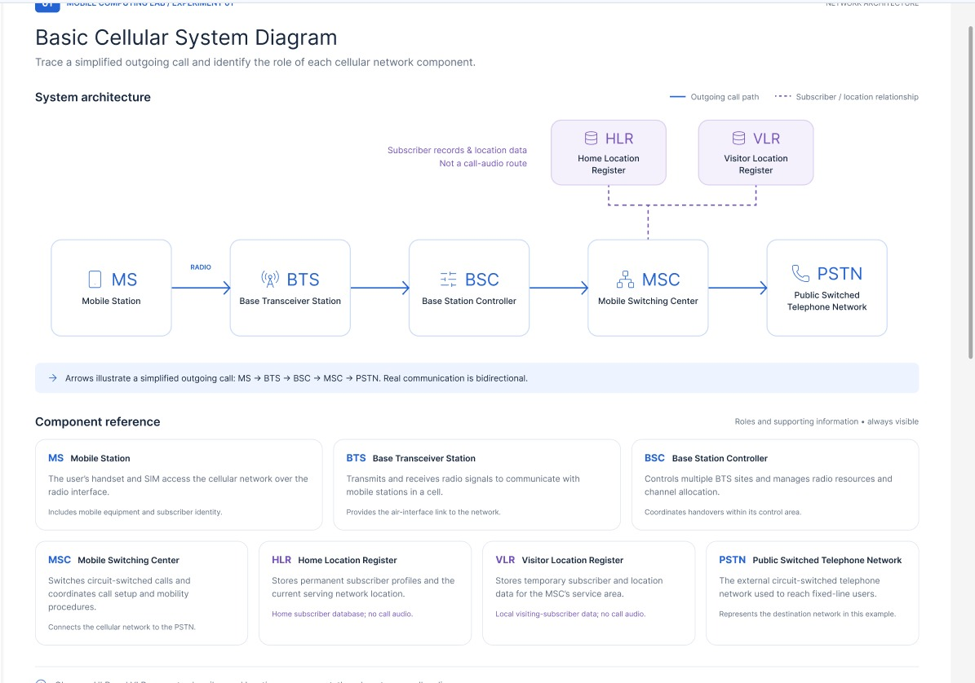
Figma design link: https://www.figma.com/design/rAXkbtmjA7ZttPAbdt2aRu/Untitled?node-id=0-1&p=f&t=hRqoAUKmtXalffm4

Result
The cellular-system diagram was designed in Figma. Test the component hotspots in Present mode and confirm that each opens its description overlay.

Experiment 2: Mobile Station UI Prototype
Question (Q2): Design a user interface prototype for a mobile station using Figma, considering connectivity and convenience.

Aim
To design a simple mobile station interface that presents communication features and connectivity controls clearly.

Theory
A mobile station combines mobile equipment and subscriber identity. Its interface allows users to make calls, access contacts and manage connectivity. Clear status indicators and accessible controls improve convenience.

Procedure
- Create an Android-sized frame named Mobile_Station_UI.
- Design a home screen with battery, signal, Wi-Fi and mobile-data indicators.
- Add a dialer screen with numeric keypad, number field and call button.
- Add a connectivity screen with Wi-Fi, Bluetooth, mobile data and airplane-mode controls.
- Use clear icons and consistent spacing.
- Link navigation buttons to the relevant screens in Prototype mode and test in Present mode.

Components and Their Functions
- Home screen: device status and shortcuts.
- Dialer: number entry and call action.
- Connectivity controls: wireless settings.
- Status bar: signal, battery and connection indicators.
- Navigation: moves between screens.

Output Design
A mobile station prototype with home, dialer and connectivity screens. Insert the Figma screenshot here.
Figmadesignlink:https://www.figma.com/design/rAXkbtmjA7ZttPAbdt2aRu/Untitled?node-id=0-1&p=f&t=hRqoAUKmtXalffm4-
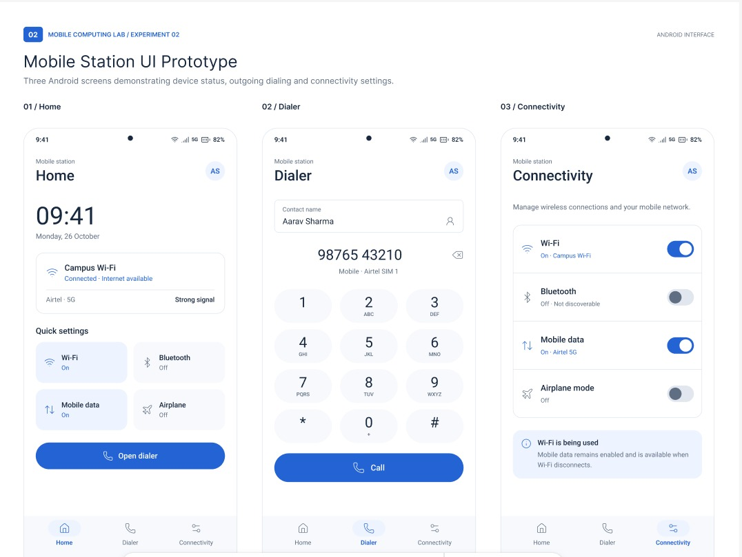

Result
The mobile station interface was designed in Figma. Verify screen navigation and controls in Present mode.

Experiment 3: Network Switching Subsystem Flowchart
Question (Q3): Develop a flowchart in Figma depicting the operation of a Network Switching Subsystem in a mobile cellular system.

Aim
To represent the main call-processing and subscriber-checking steps of a GSM Network Switching Subsystem using a flowchart.

Theory
The NSS manages switching, subscriber information and connections to other networks. The MSC handles call control; HLR and VLR provide subscriber information, and AuC supports authentication. Procedures vary by network and service.

Procedure
- Create a frame named NSS_Flowchart.
- Use ovals for Start/End, rectangles for processes and diamonds for decisions.
- Draw: Start → Call request → MSC receives request → Authentication using AuC → Authentication successful? No → Reject request → End.
- Yes → Check subscriber information using HLR/VLR → Locate destination → Route call → Establish connection → Conversation → Call termination → Update records → End.
- Label Yes/No branches, connect all symbols with arrows and add a side panel explaining MSC, HLR, VLR and AuC.

Components and Their Functions
- MSC: call setup, routing and release.
- HLR: permanent subscriber information.
- VLR: temporary subscriber information.
- AuC: authentication support.
- Decision node: authentication outcome.

Output Design
A flowchart showing call request, authentication, routing, connection and termination. Insert the Figma screenshot here.
Figmadesignlink:https://www.figma.com/design/rAXkbtmjA7ZttPAbdt2aRu/Untitled?node-id=0-1&p=f&t=xrD3PUh5wBDgToeH-0

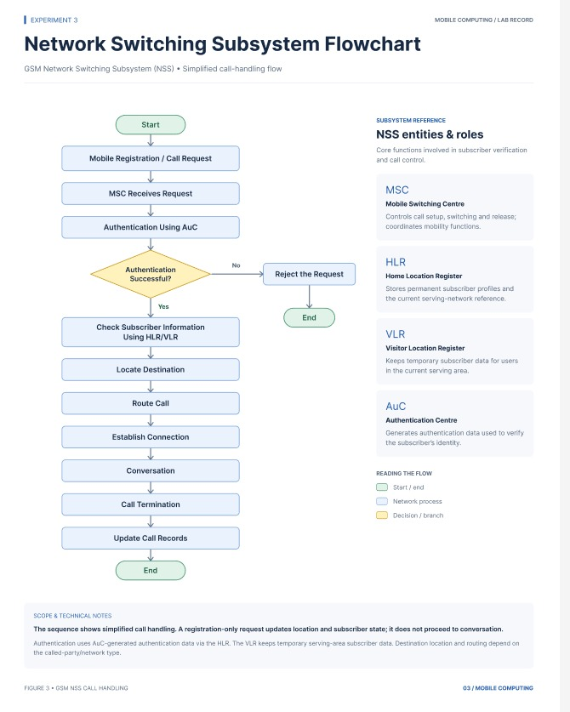

Result
The NSS operation was represented in Figma. Check that every decision branch and arrow leads to the correct step.

Experiment 4: Mobile Network Protocol Stack
Question (Q4): Create a visual representation in Figma highlighting the key elements of mobile network protocol stacks.

Aim
To create a layered diagram explaining the purpose of common network protocol layers.

Theory
Protocol stacks divide communication into layers, each with a specific task. A simplified Internet-style stack includes application, transport, network, data-link and physical layers. Cellular standards may use different layer names and structures.

Procedure
- Create a frame named Mobile_Protocol_Stack.
- Draw five vertical layers: Application, Transport, Network, Data Link and Physical.
- Add examples and functions: mobile apps/services; TCP/UDP; IP addressing and routing; framing/link control; radio or physical transmission.
- Draw arrows downward for transmission and upward for reception.
- Add smartphone and wireless base-station icons.
- Note that this is a simplified conceptual model.

Components and Their Functions
- Application: user-facing services.
- Transport: end-to-end data transport such as TCP/UDP.
- Network: addressing and routing.
- Data Link: framing and link delivery.
- Physical: transmission of bits using signals.

Output Design
A colored protocol-stack diagram with layer names, examples and arrows. Insert the Figma screenshot here.
Figmadesignlink:https://www.figma.com/design/rAXkbtmjA7ZttPAbdt2aRu/Untitled?node-id=0-1&p=f&t=xrD3PUh5wBDgToeH-0

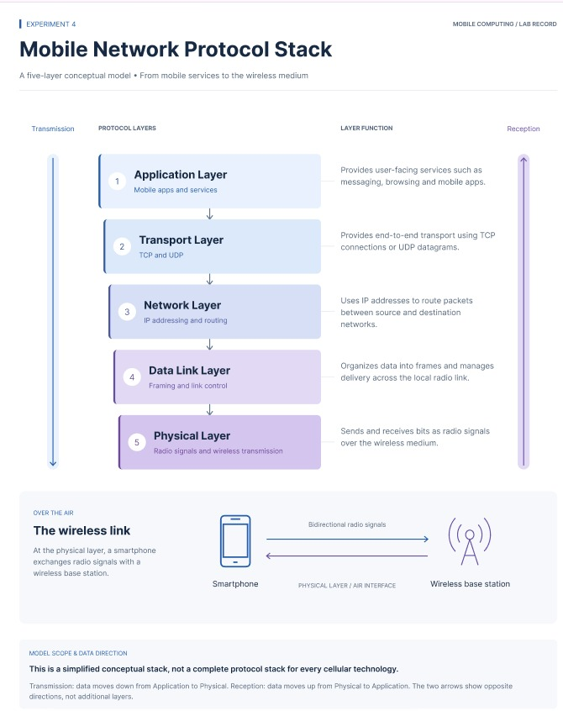

Result
The protocol stack was visualized in Figma, showing the purpose of each layer and data-flow direction.

Experiment 5: Mobile Application with Localization Features
Question (Q5): Design a wireframe for a mobile application that incorporates localization features using Figma.

Aim
To design a mobile wireframe that lets users select a language and regional preferences.

Theory
Localization adapts an application’s language, formats and content to a user’s region. Common settings include language, date and time formats, and location. Localized interfaces should remain readable across languages.

Procedure
- Create an Android frame named Localization_App.
- Design a home screen with welcome message, location and settings.
- Create a language-selection screen with English, Tamil, Telugu, Hindi and Malayalam.
- Create a regional-settings screen with location, date format, time format and preference controls.
- Add a Save Preferences button.
- Connect the screens in Prototype mode and link language choices to a localized preview screen.

Components and Their Functions
- Language selector: chooses display language.
- Location setting: selects region/location.
- Date/time settings: regional formats.
- Save button: saves preferences in the prototype flow.
- Preview: demonstrates localized text.

Output Design
A wireframe containing home, language selection, regional settings and localized preview screens. Insert the Figma screenshot here.
Figmadesignlink:https://www.figma.com/design/XiuanRCVNJkTs3EEIhZiR0/Untitled?node-id=0-1&p=f&t=r6s9bR5boELXghlR-0

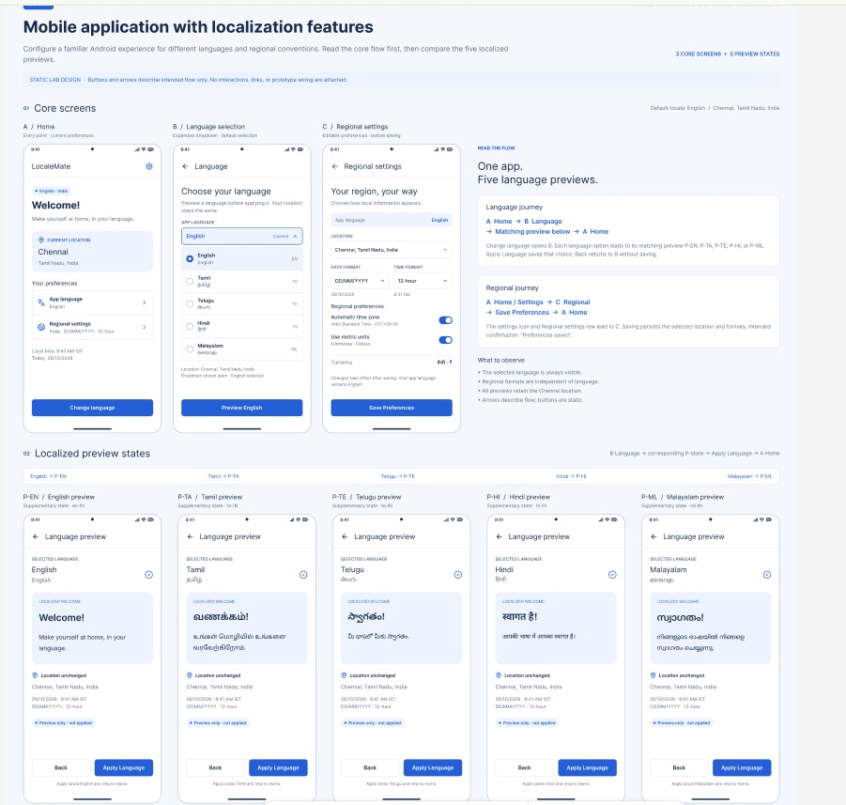

Result
The localization wireframe was designed in Figma. Test the screen links and confirm the selection flow is clear.

Experiment 6: Handoff Scenario in a Mobile Network
Question (Q6): Use Figma to simulate a handoff scenario in a mobile network and visualize the process.

Aim
To visualize how an active mobile connection transfers from one serving cell to another as a user moves.

Theory
Handoff, or handover, transfers an active connection from one cell or serving base station to another because of movement, signal conditions or network management. Its goal is to maintain service during the transfer.

Procedure
- Create a frame named Cellular_Handoff_Simulation.
- Draw two overlapping cells with Base Station 1 and Base Station 2.
- Place a phone in Cell 1 and draw its movement toward Cell 2.
- Show stages: connected to Station 1; movement toward boundary; Station 1 signal weakens; Station 2 signal strengthens; network transfers connection; call continues.
- Connect both stations to a network controller/MSC.
- Create separate stage frames and connect them with a Start Handoff button in Prototype mode.

Components and Their Functions
- Serving base station: initial connection.
- Target base station: destination connection.
- Signal indicators: changing signal conditions.
- Handoff decision: transfer point.
- Active call: illustrates service continuity.

Output Design
A staged handoff diagram showing movement between two cells and connection transfer. Insert the Figma screenshot here.
Figmadesignlink:https://www.figma.com/design/XiuanRCVNJkTs3EEIhZiR0/Untitled?node-id=0-1&p=f&t=r6s9bR5boELXghlR-0

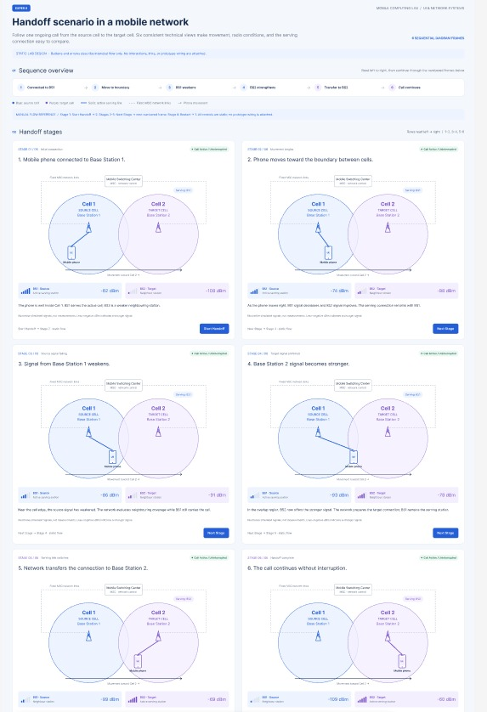

Result
The handoff scenario was visualized in Figma. Test the prototype stages to ensure the transfer is clear.

Experiment 7: Cellular System Performance Dashboard
Question (Q7): Develop a dashboard prototype in Figma displaying performance criteria for a cellular system.

Aim
To design a dashboard summarizing key cellular network performance indicators in a clear visual format.

Theory
Network performance can be assessed using signal strength, throughput, latency, call success rate, traffic load and availability. A dashboard combines indicators for monitoring. Prototype values are illustrative, not live measurements.

Procedure
- Create a desktop frame named Cellular_Performance_Dashboard.
- Add KPI cards for signal strength (-75 dBm), network speed (45 Mbps), latency (28 ms) and call success rate (98.5%).
- Add a line chart for speed over time, a bar chart for traffic by cell, and a donut chart for availability.
- Include network status, active base-station count and a weak-signal alert.
- Add navigation for Dashboard, Network Status, Performance and Settings.
- Label all values as sample data.

Components and Their Functions
- Signal strength: illustrative received level.
- Throughput: illustrative data rate.
- Latency: illustrative response delay.
- Call success rate: illustrative successful call proportion.
- Charts/alerts: summarize trends and issues.

Output Design
A dashboard with KPI cards, charts, status information and alerts. Insert the Figma screenshot here.
Figmadesignlink:https://www.figma.com/design/il7OFeO4fSjUZutkgrSQbT/Untitled?node-id=0-1&p=f&t=VmSvCjLR7S5Imc9a-0

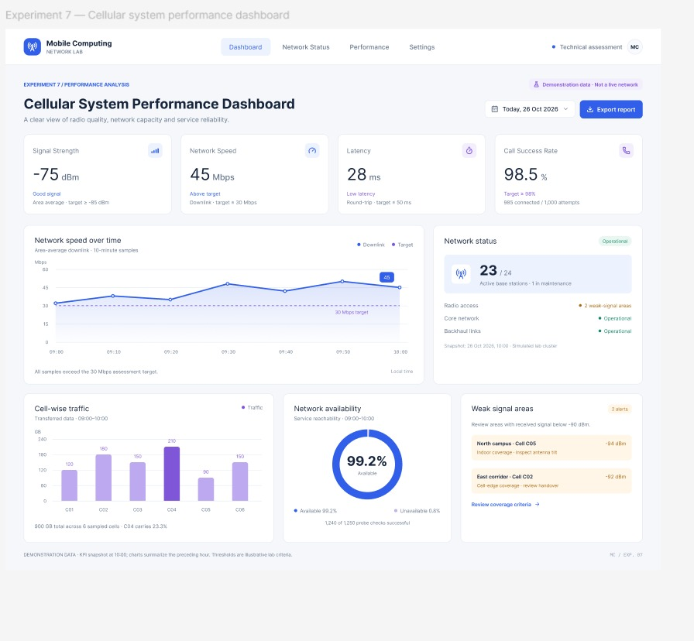

Result
The cellular performance dashboard was designed in Figma. Confirm that sample metrics and charts are clearly labeled.

Experiment 8: Public Land Mobile Network (PLMN) Infographic
Question (Q8): Create an infographic in Figma explaining the concept of Public Land Mobile Network (PLMN).

Aim
To explain the purpose, components and basic working of a PLMN through an infographic.

Theory
A PLMN is a mobile communication network provided by an operator for public users. It includes radio access and core-network components and supports voice, messaging, data and roaming. It is commonly identified using a Mobile Country Code (MCC) and Mobile Network Code (MNC).

Procedure
- Create an infographic frame named PLMN_Overview.
- Add a title and definition.
- Show Mobile Station, BTS, BSC, MSC and subscriber/security databases.
- Use arrows to show Mobile Phone → Radio Access Network → Core Network → External Network.
- Add voice, SMS, mobile data, roaming and authentication services.
- Explain MCC and MNC in a small identity panel.
- Use clear icons, concise text and consistent colors.

Components and Their Functions
- Mobile Station: user device.
- Radio access network: connects device to operator.
- Core network: routes services and manages mobility.
- Services: voice, SMS, data and roaming.
- MCC/MNC: codes identifying country and mobile network.

Output Design
An infographic showing PLMN definition, components, services and network identity. Insert the Figma screenshot here.
Figmadesignlink:https://www.figma.com/design/il7OFeO4fSjUZutkgrSQbT/Untitled?node-id=0-1&p=f&t=VmSvCjLR7S5Imc9a-0

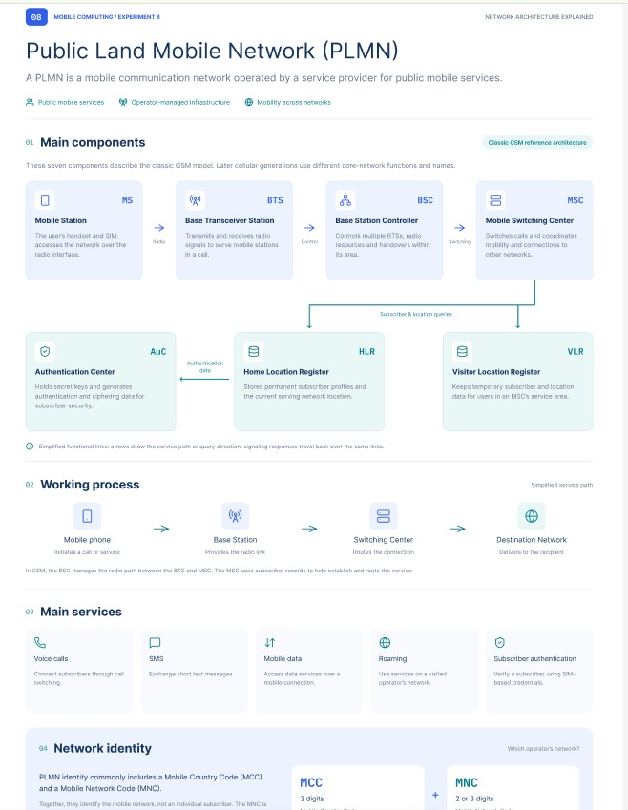

Result
The PLMN infographic was created in Figma and presents its components and services visually.

Experiment 9: GSM Service UI Prototype
Question (Q9): Develop a user interface prototype for a GSM service using Figma.

Aim
To design a mobile interface prototype demonstrating common GSM services such as calling, SMS and contacts.

Theory
GSM is a second-generation cellular standard supporting digital voice communication, SMS and related mobile services. A service interface gives users access to calls, messages, contacts and network status.

Procedure
- Create an Android frame named GSM_Service_UI.
- Design a home screen with SIM status, operator, signal strength and network type.
- Add a dialer screen with keypad, number field and call button.
- Add an SMS screen with message list, composition field and Send button.
- Add a contacts screen with search, saved contacts and add-contact button.
- Link Home, Dialer, SMS and Contacts in Prototype mode and test in Present mode.

Components and Their Functions
- Home: SIM and network status.
- Dialer: phone-number entry.
- SMS: messages and composition area.
- Contacts: saved contacts and search.
- Navigation: links the screens.

Output Design
A GSM service prototype with home, dialer, SMS and contacts screens. Insert the Figma screenshot here.
Figmadesignlink:https://www.figma.com/design/r73jmrv7rr4nqLrsYRSYBW/Untitled?node-id=0-1&p=f&t=e1KWUdtAN6nxbdNo-0

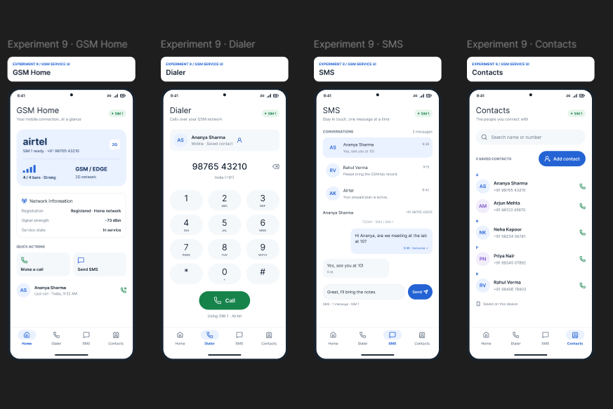

Result
The GSM service UI was designed in Figma. Verify navigation between all four screens in Present mode.

Experiment 10: Multiple Access Techniques
Question (Q10): Create a visual representation in Figma showcasing the differences between various multiple access techniques.

Aim
To compare FDMA, TDMA and CDMA using simple diagrams and a summary table.

Theory
Multiple access techniques allow multiple users to share radio resources. FDMA separates users by frequency, TDMA separates transmissions by time slots, and CDMA allows users to share time and frequency using different spreading codes.

Procedure
- Create a frame named Multiple_Access_Comparison.
- Divide it into FDMA, TDMA and CDMA sections.
- Draw a frequency-versus-time diagram with separate frequency bands for FDMA.
- Draw time slots for TDMA users sharing a carrier.
- Draw CDMA users sharing time/frequency with different spreading codes.
- For each, add full form, definition, one advantage and one limitation.
- Add a comparison table for resource separation, sharing method and key characteristic.

Components and Their Functions
- FDMA: Frequency Division Multiple Access; separate frequency bands.
- TDMA: Time Division Multiple Access; separate time slots.
- CDMA: Code Division Multiple Access; different spreading codes share time/frequency.
- Comparison table: summarizes differences.

Output Design
A three-part infographic with FDMA, TDMA and CDMA diagrams plus a comparison table. Insert the Figma screenshot here.
Figmadesignlink:https://www.figma.com/design/r73jmrv7rr4nqLrsYRSYBW/Untitled?node-id=0-1&p=f&t=e1KWUdtAN6nxbdNo-0

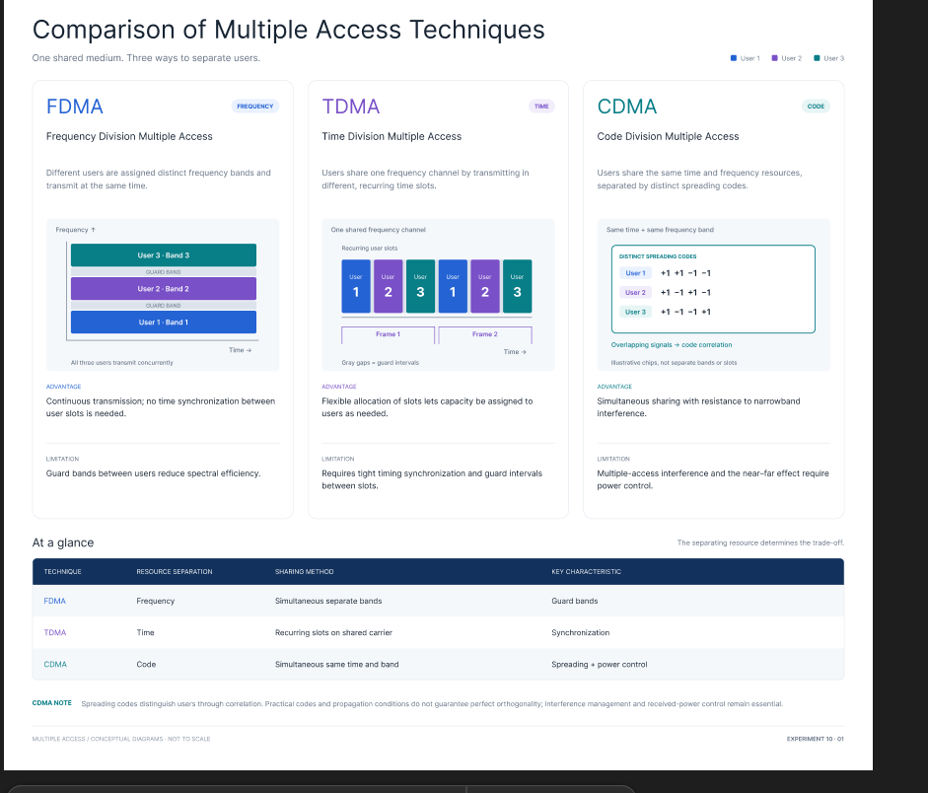

Result
The multiple access techniques were compared visually in Figma, highlighting their different ways of sharing radio resources.

